National University of Computer and Emerging Sciences



Lab Exercise 10

AL2002-Artificial Intelligence Lab

|  |  |
| --- | --- |
| Course Instructor | Dr. Hajra Waheed |
| Lab Instructor (s) | Hamza Ayub  Muhammad Ahmed |
| Sections | B1 - B2 |
| Semester | Spring 2023 |

Department of Computer Science

FAST-NU, Lahore, Pakistan

# Exercise (40 Marks)

Attempt all tasks given below.

## Make a Soccer Player Weight Pie Chart (20 Marks)

Consider the following dataset: **fifa_data.csv**

Make a pie chart using Matplotlib, similar to the one shown below:

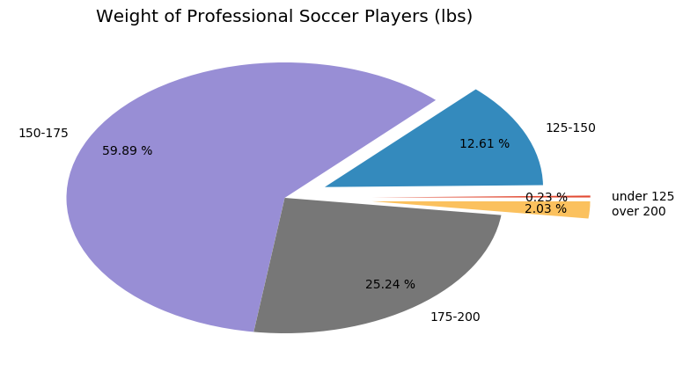

## Plotting using SeaBorn (20 Marks)

Consider the following dataset: **fifa_data.csv.**

Find Correlation between all the columns with each other . Make a Heatmap using seaborn library and also show the correlation values in Heatmap.

Also Generate Pairs Plots with Seaborn for **Age**, **Overall** and **Potential.**